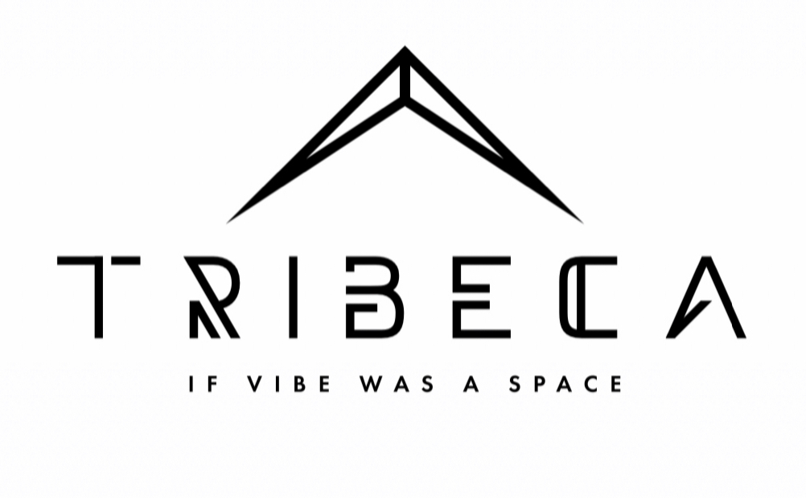

**TRIBECA HTX**

**Venue Contract**

Event Date:

Event Start Time:

Guest Count:

Client:

Address:

Company:

Email:

**Note:** A signed contract and non-refundable deposit equal to fifty percent (50%) of your rental fee must be received to reserve your date(s) and time(s). If your date is less than 30 days, full quoted amount must be paid

* A separate credit card authorization/hold will be obtained for a damage deposit in the amount of $500. If damages are found client will be informed as to the damages and the amount. If no damages are found the deposit fee shall be released within 48hrs. Damage Deposit is due the day of the event.
* The balance of your space rental fee is due thirty (30) days prior to your event and is non-refundable
* Additional and miscellaneous costs, such as bar, catering, furniture, and equipment rental etc. that arise will be due within seven (7) days prior to event date.
* An additional charge will be billed for time past the stated event end time at $175/hour unless authorized by **TRIBECA HTX**.
* A copy of your Special Event Liability Insurance is due fourteen (14) days prior to your event. (Not Applicable)
* If Caterer is not on a Preferred Vendor List then a COI must be provided.

***Payments: All invoices will be sent via email click and pay Zelle or Venmo

Renters agree acknowledge the rental deposits are non-refundable and any balance owed for rental space fee will be paid 30 days prior to the event date as per the agreement to rent Tribeca HTX on the date above that may cause loss of additional bookings or business for said date. Reserved food and beverage catering, along with rentals and/or purchases necessary to produce your event may not be refunded, or may not be refunded in full if costs incurred toward that obligation has not incurred.

**Acknowledged, Agreed and Authorized by Primary**

**Contact/Renter _________________ Date: _________**

**EVENT SPACE RENTAL AGREEMENT AND CONTRACT CONDITIONS AND**

**RESPONSIBILITIES OF RENTER**

Please read the material below to make sure that you understand the requirements for everyone’s safety and keeping **TRIBECA HTX**, a well maintained and safe location

**RENTAL FEES/DEPOSIT**

Day

Cleaning fee $ 175

**TOTAL**

Damage Deposit $500 ( held the day of the EVENT) (refunded after without incident) CC cash or money order accepted

***Rental items TBD…

**Please Note if Alcohol is being served you security is required at and additional cost TBD

A signed contract and NON-Refundable deposit is due at the time of booking in the amount of fifty (50%) of your rental fee must be received reserve your date(s) and time(s). Your balance is due thirty (30) days prior to your event. If your event is within this timeframe the full quoted amount MUST be paid. A Pay In Full Invoice will to sent via email click and pay Zelle or Venmo

Damage deposit of $500 is due the day of the event. A separate credit card authorization/hold will be given on the day of event or client may bring a money order Client must will take out trash and all decor from venue

**INSURANCE COVERAGE FEE**

Renters at Renter’s sole expense is required to secure Special Event Liability Insurance fourteen (14) days before said event. We can provide a quote for insurance if needed. (Waived) Approved Caterers and /or vendors, companies, and/or institutions MUST provide a copy of Certificate of Insurance and Catering License to TRIBECA HTX, naming TRIBECA HTX additional insured at least 2 weeks prior.

If alcohol is to be served please be sure that the policy includes Host Liquor Liability coverage to protect you against alcohol-related accidents, as you are ultimately liable for the safety of your guests. Established Catering Services May use their license and insurance to cover this.

**LIABILITY**

Renters agree to protect, indemnify, defend, and hold harmless, TRIBECA HTX, it’s landlord, building owners, officers, employees, and agents all claims, losses, liabilities, damages, to persons or property, government charges or fines and costs or expenses (including attorney fees) arising out of and/or connected with the rental use of the premises,

In the event TRIBECA HTX, it’s landlord, building owners, officers, employees, and/or agents, are required to file any actions in court in order to enforce any provisions of this agreement, Renter agrees to pay TRIBECA HTX, it’s officers, landlord, building owners, employees, and/or agents, all responsible attorney fees, court fees, and costs of suit incurred by TRIBECA HTX, including all collection expenses and interest due

**Acknowledged, Agreed and Authorized by Primary**

**Contact/Renter _________________ Date: _________**

**CAPACITY**

The rental space has a maximum capacity of 250-300 persons. You agree and acknowledge that at no time during your event will the number of total guest exceed the maximum allowed capacity.

**SECURITY**

Renters must hire (2) security officers per 100 people with TRIBECA HTX preferred security during events with alcohol. Security costs will be $60/hour/person

**SITE DECORATION**

TRIBECA HTX has a very strong design team, but we respect your decision to use an outside designer. TRIBECA HTX, wants to make every event a special and welcoming experience. Therefore, every effort will be made to allow Renters to prepare decorations reflecting their creative vision. We ask that only TRIBECA HTX staff move any furniture owned by TRIBECA HTX including artwork vases, candles, florals & trees. No nails, screws, staples, or penetrating items are to be used on the walls or floors. The use of glitter, foil, confetti, rice, bird seeds or beads is strictly prohibited on the site. You agree to pay for any damages/repair and authorize us to charge your credit card on file after your event

***Event will be using non-damaging adhesive to attach any decor Removal of All Decir and Trash

**CONDUCT**

No drug use is permitted in the premises

**LIVE MUSIC/DJ/NOISE**

TRIBECA HTX encourage music and fun, but please be aware that we are in a mixed development with residential directly behind our building and therefore, neighborhood noise regulations do apply. Please be aware of load bass noise that violates noise regulations. In the event that the Renters event creates a disturbance due to high noise volume or bass, TRIBECA HTX’s on-site manager/staff has full authority to ask Renters, DJ or live music producer/entertainer to turn down the music or shut it off completely! In the event of disturbances, where the event is shut down, no portion of the event costs will be refunded to Renter.

Loud music must end by 12 am weekday and 2 am weekends (Friday and Saturday). Additional

time can be added upon request provided the volume is modest and cannot be heard beyond the boundaries of our property.

**Acknowledged, Agreed and Authorized by Primary**

**Contact/Renter _________________ Date: _________**

**VALET PARKING/ON-SITE PARKING**

Valet parking or Parking Lot Attendants will be provided at an additional cost to guest. Street parking available 

**CANCELLATION**

Your deposit to save the date is NON-REFUNDABLE

NO Additional PAYMENT(S) WILL BE REFUNDED after 45 Days before event

**LOAD-IN/LOAD-OUT and STORAGE**

Please use rear door for loading and unloading. There is no timeframe you are given the full day access for your event. Limited storage is available upon request. Storage fees may apply unless otherwise authorized by TRIBECA HTX

**CLEANING, RESTROOM ATTENDANT, TRASH AND EQUIPMENT REMOVAL**

In addition to rental fee you will be charged and additional $175 cleaning fee for cleaning. You are still responsible for cleaning up your event and all trash and decor taken out. Our crew will clean basics such as mopping, windows and bathroom.

**Acknowledged, Agreed and Authorized by Primary**

**Contact/Renter _________________ Date: _________**

\*\*\***\*Any additional services can be added and This contract is subject to be revised**